Bearing Up – Useful Resources/Ideas List
Setting a Context for ‘A Bearing Up Approach’ and embedding Bear into our Classrooms.
‘Regulation Trolley’ – 3-Tiered Trolley Hobbycraft (£30 – discounts often available) 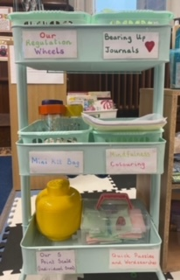
Ear Defenders – Available on numerous Educational Resource Sites -prices vary
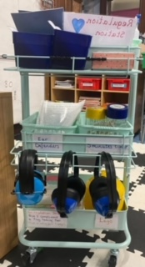
Mini Kit Bag – International Future Forum (IFF) Website £21-£26 (Puppet/Oil/Wonder Journey added as extra)
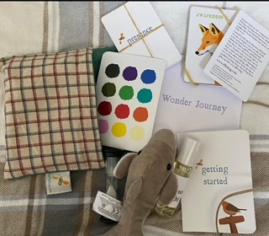
Full Size Kit Bag – International Future Forum (IFF) Website £60
Includes Animal Cards, Presence Cards, 1min Timer, 2 Puppets, 1 Essential Oil, Talking Stick, Wonder Journey, Emotion Colour Card.
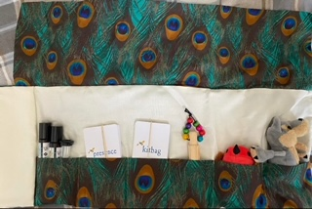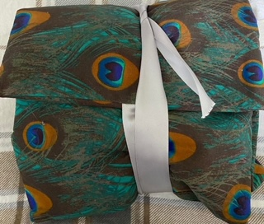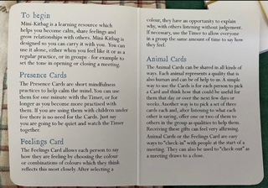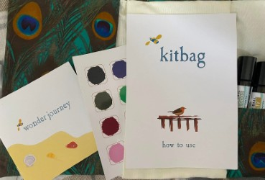

‘Fizzy Feelings’ Triggers Poster – created by the pupils/class and unique to their needs.
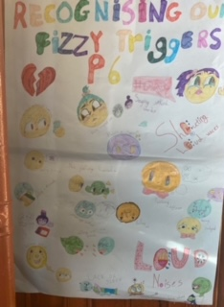

‘All Feelings Matter’ Emotions Display Bottle – handmade on large card. Emotions and colours link to Inside Out Movie/Characters as well as Bearing Up Story. Joy/Calm is horizontal other emotions run vertical to demonstrate all equally valued and can have more than one at a time. *Updated version is for the Zones of regulation. (Both include synonyms for all the emotions as seen in poster for older classes – can be as part of a lesson. Simplify for younger classes.)
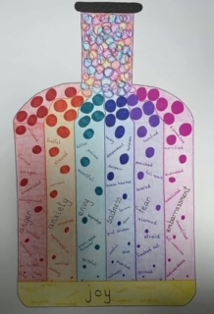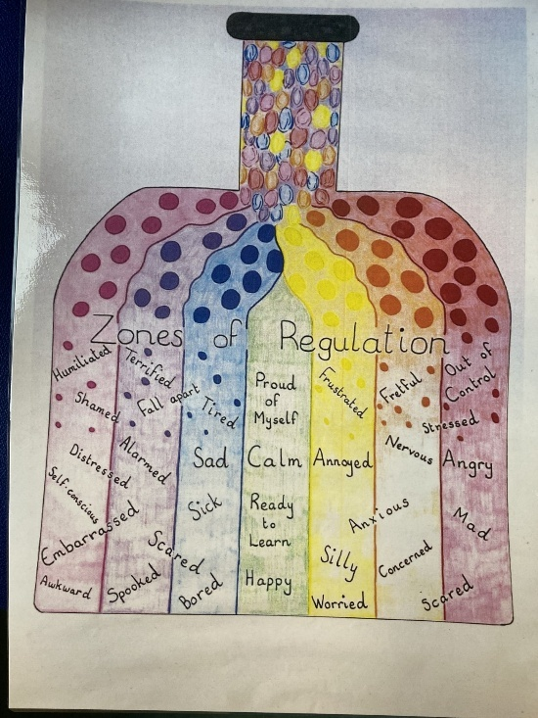
‘Fizzy Feelings Matter’ self-registration chart. (Children not forced to use this and only used once introduced as part of a kind, safe and respectful classroom.)
*Update – change to ‘All Feelings Matter’
Empty Chart Case from PTS (Primary Teaching Services – CertiCARD Holder) £12
Emotion cards hand made using cut card and laminated – credit card size and heart stickers (Amazon)
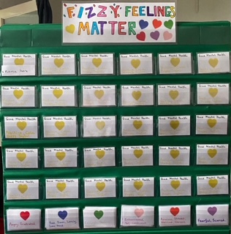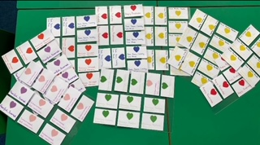
Individual Bear Charts for younger pupils to create and share their feelings.
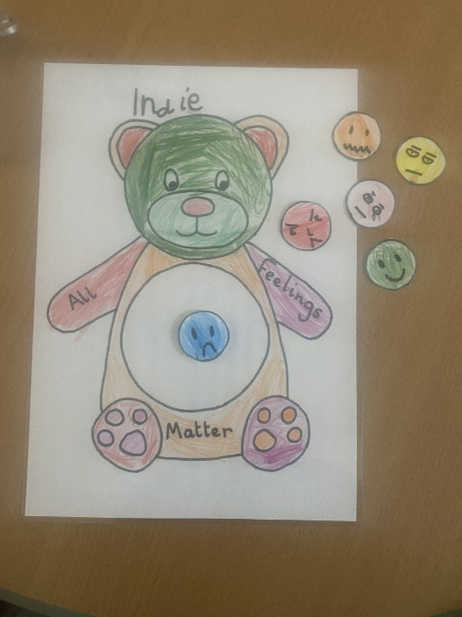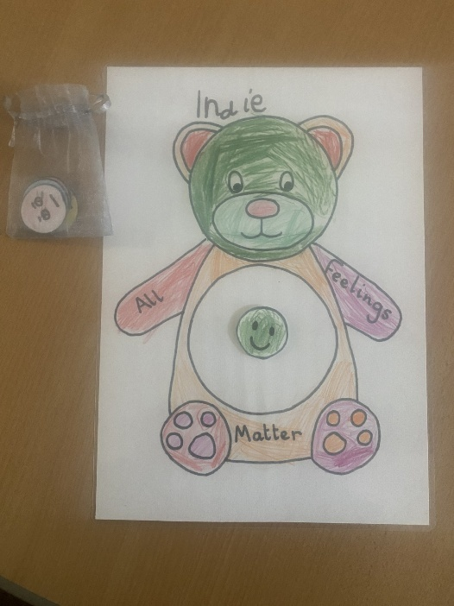

Morning Greetings Poster – Handmade with the pupils. Purpose is to be present as your pupils enter to show you value and are putting them first. Opportunity to tune in to how your pupils are feeling as the enter – looking out for any subtle changes in how they greet you over time. Chance to check in before a pupil may become overwhelmed etc…
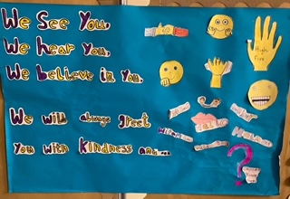

Compliments ‘Jar’ made by pupils – children can pre-make as part of a kindness lesson and give/gift to their peers when they are feeling ‘Fizzy.’ One compliment per time – Pupils tuning in to understand and show empathy to peers. Can be popped by their name on Fizzy Chart if using one or can have their own/make weaved kindness buckets. Can also use small metal buckets and pop on child’s desk that needs one at the time. Lots of options. Can also use motivational quote stickers as well/instead.
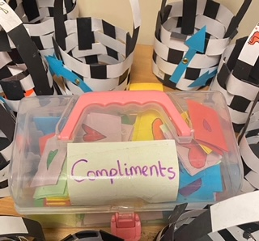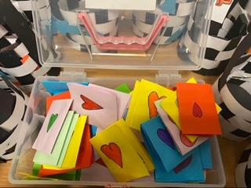
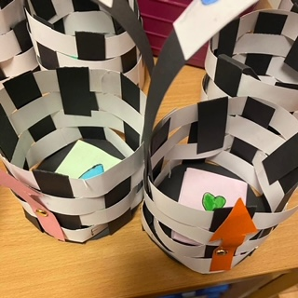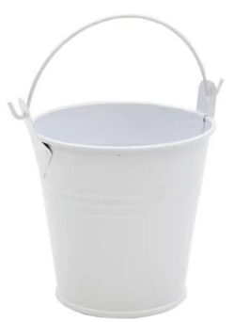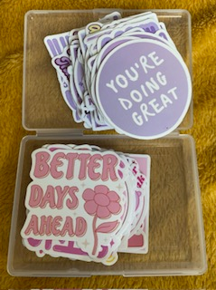

‘Bear Stop’ – Adaption of ‘Team Stop’ command used in class.
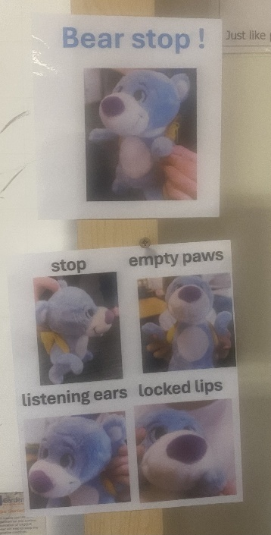

Letter from Bear Templates – can be copied/used.
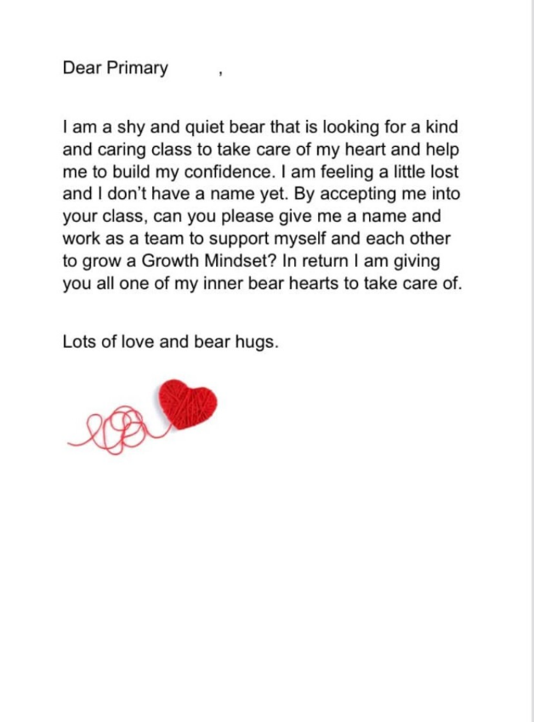
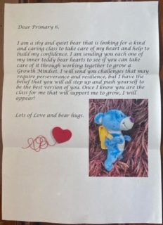

Bear Mini Story and Bear Adoption Certificate – can be sent as PDFs on request.
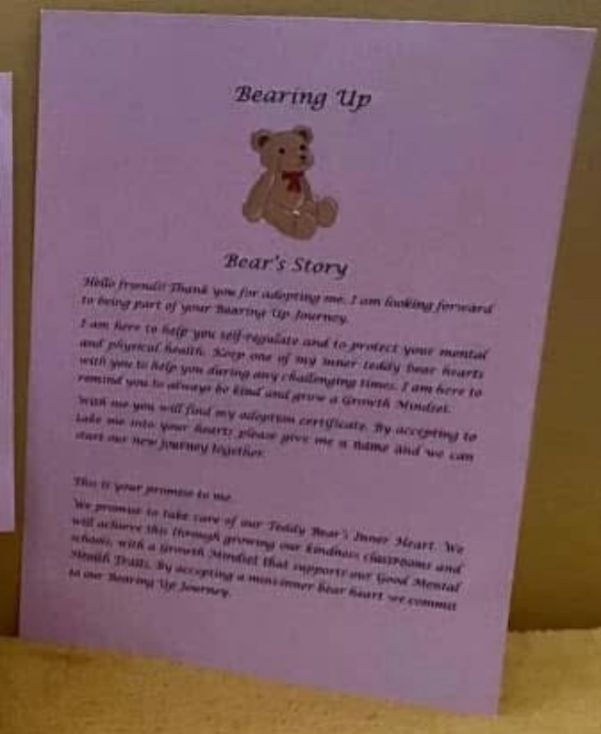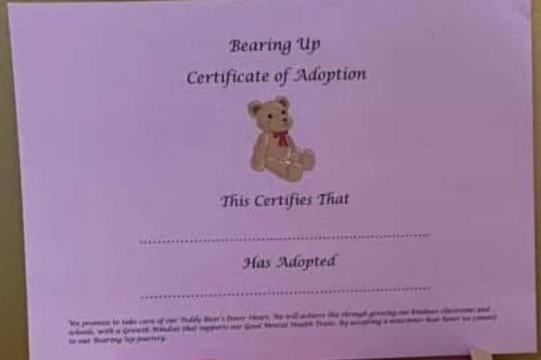

Updated Bear Mini Growth Mindset Story and Adoption certificates.
Kindly created by Kirsty Cairns (a member of our Bearing Up Project Family FB)
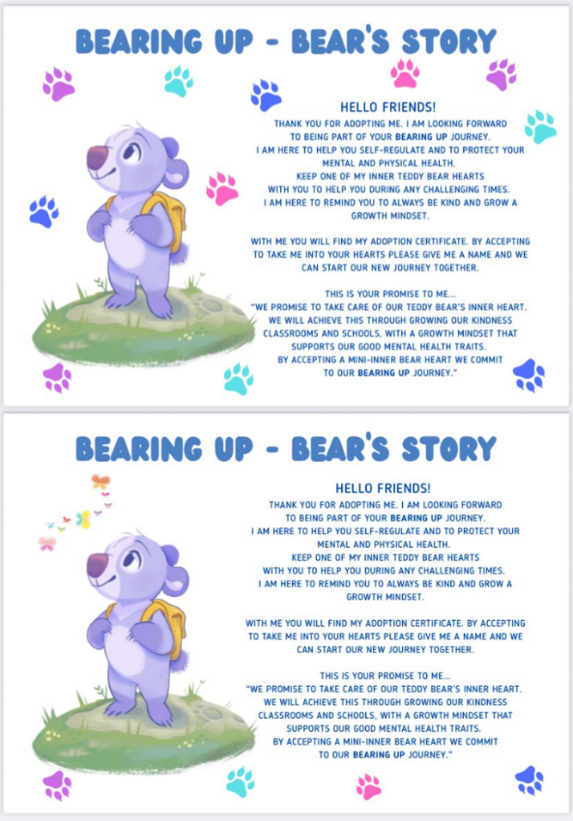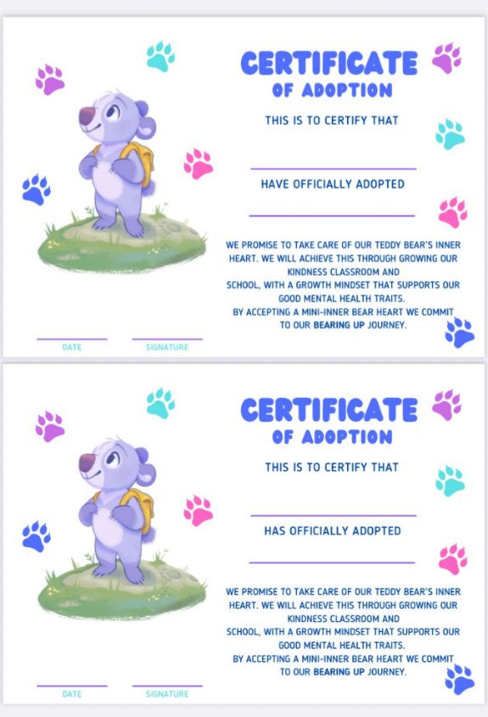
Bear’s Proud Cloud/@Bear Check-Out (Exit Ticket) Sharing academic learning, wider achievements and growth mindset/kindness and connection.
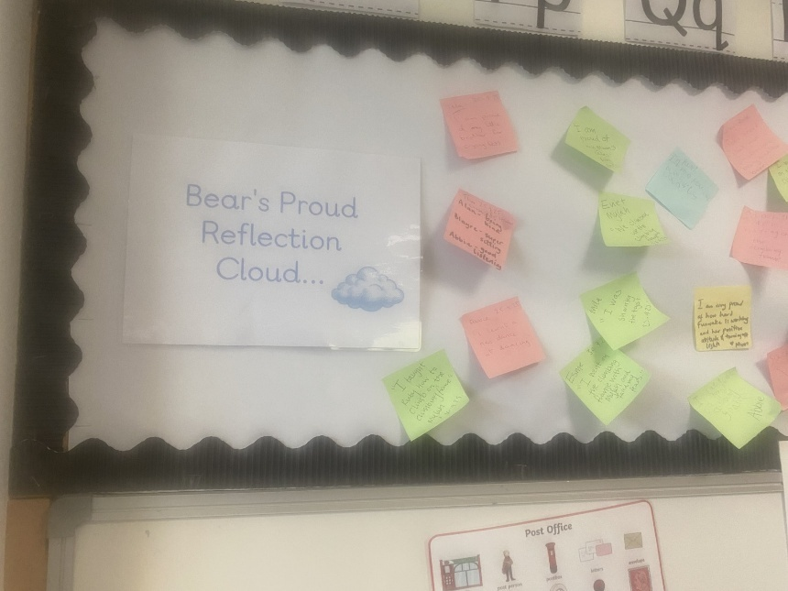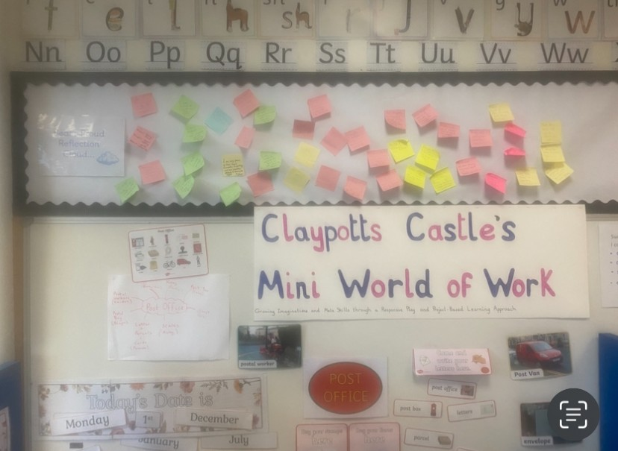
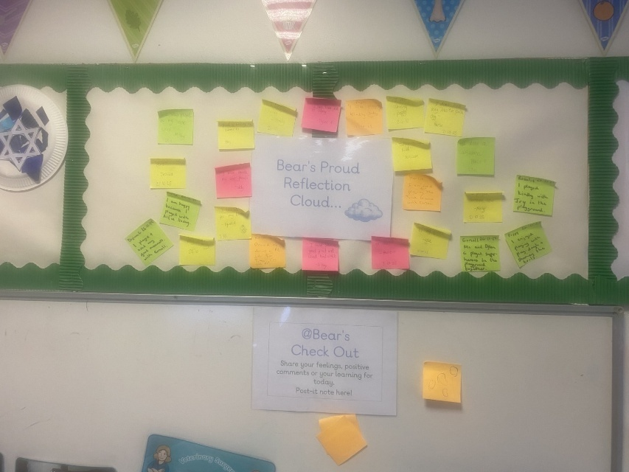
Bearing Up Journals – Older pupils can free write to use as a diary entry. Younger Pupils can use with teacher support and built into writing/daily or weekly write. P2 Examples.
Option to comment and sign from Bear! Can link to other curricular areas.
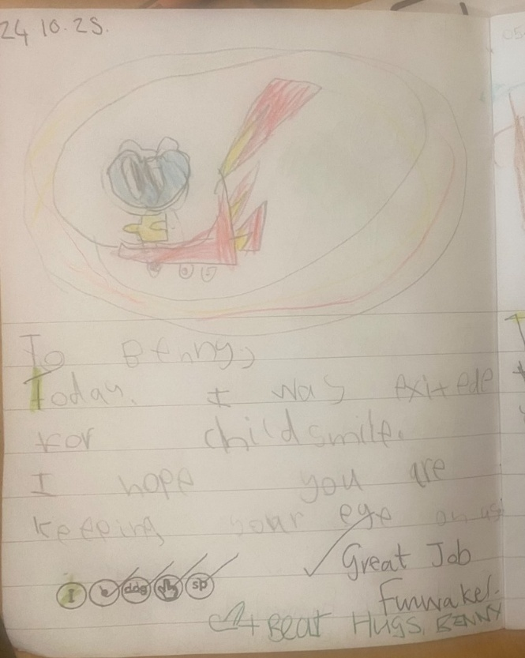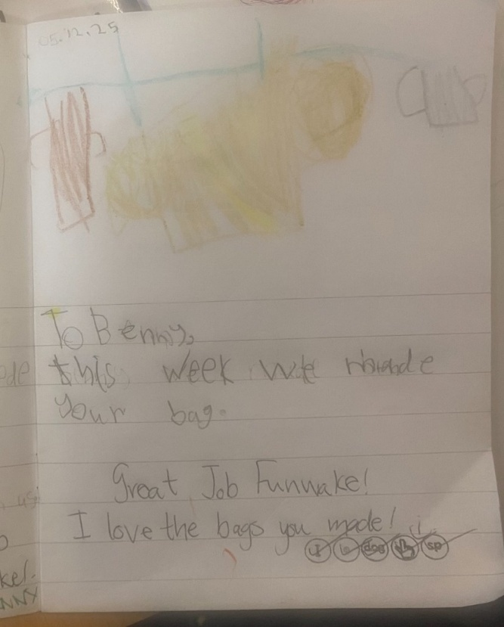
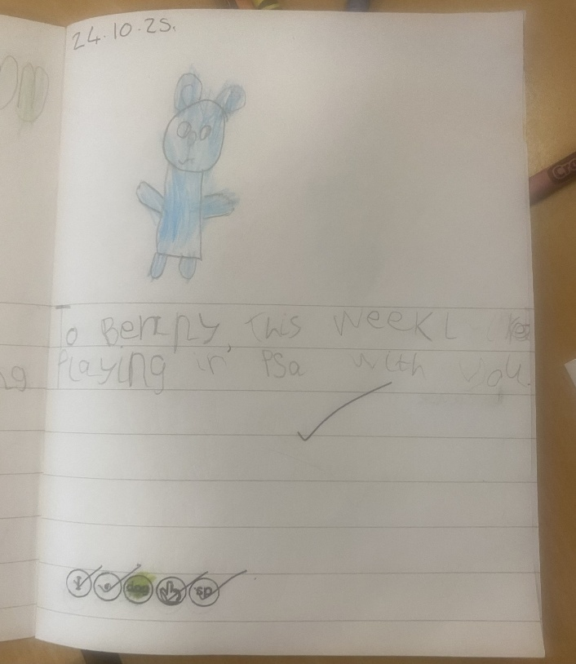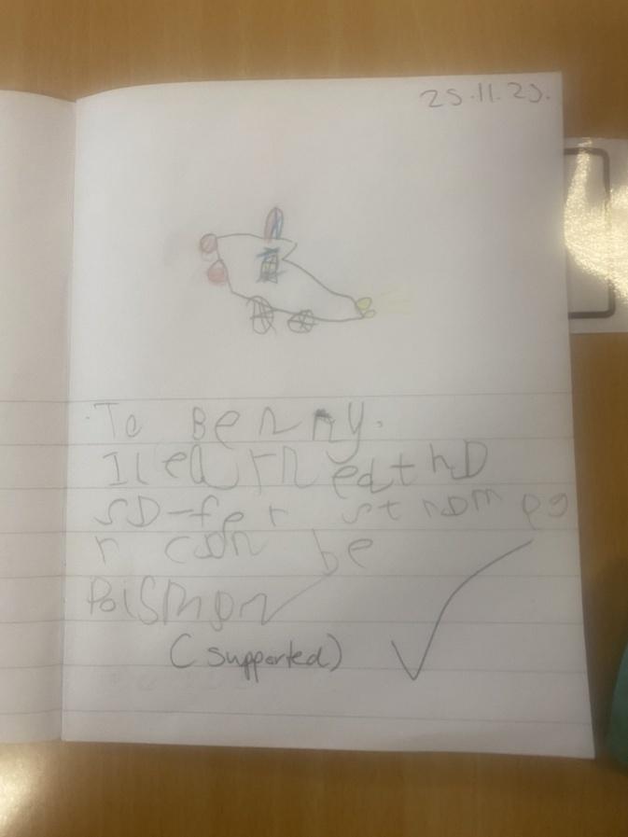

Can support Logical Consequences. The childen have made their promise to Bear at the start of their journey. Bear can leave for a bit if good choices are not being made as a class team. Everyone is responsible. Example letter from P2s bear who had to have a break for a week! The children wrote to bear to express how they felt about him leaving and their/ or their peers’ actions. Accountability is essential for building GRIT and central to our ‘Bearing Up’ Journey.
Letter to the children in their Journals who always make good choices.
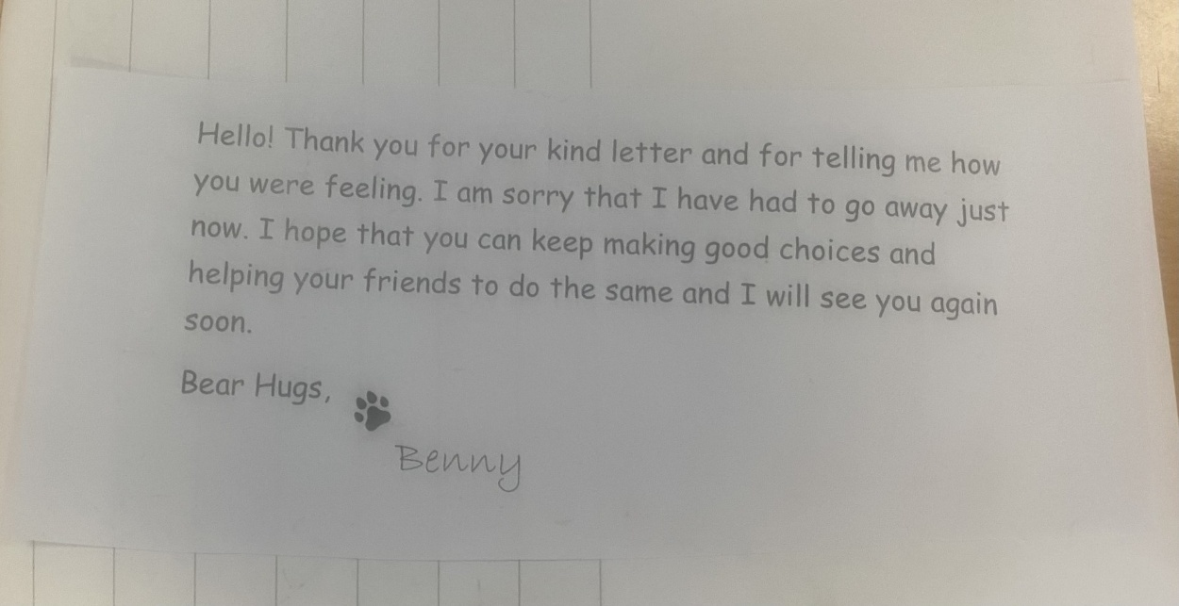
Letter to the children in their Journals not making good choices.
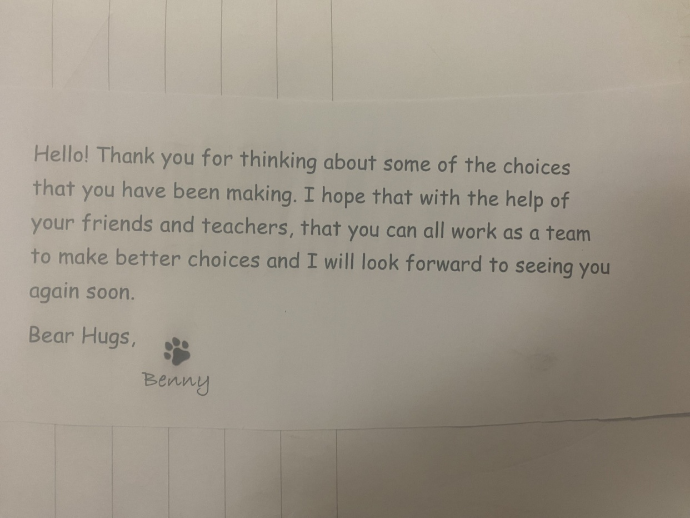
Zones Of Regulation and Green Thoughts/Red Thoughts through the Context of Bear
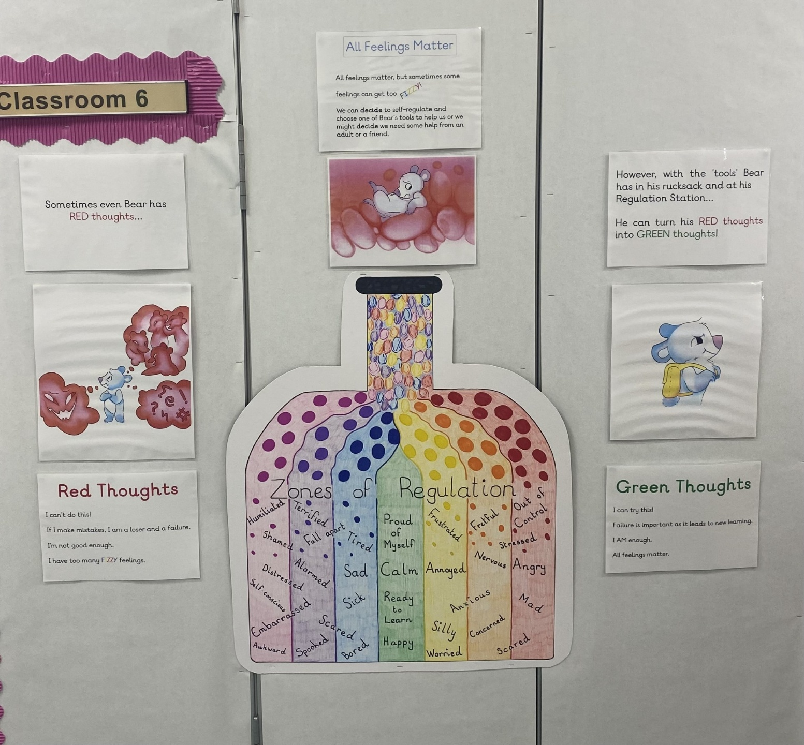

Mrs Murray’s (P2) Bear’s Calm Cave
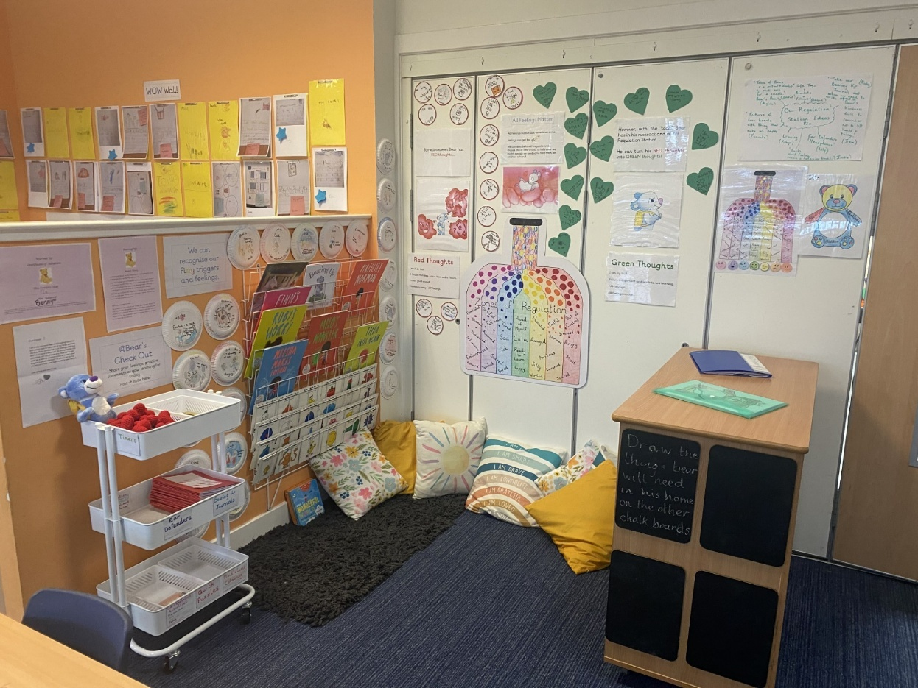
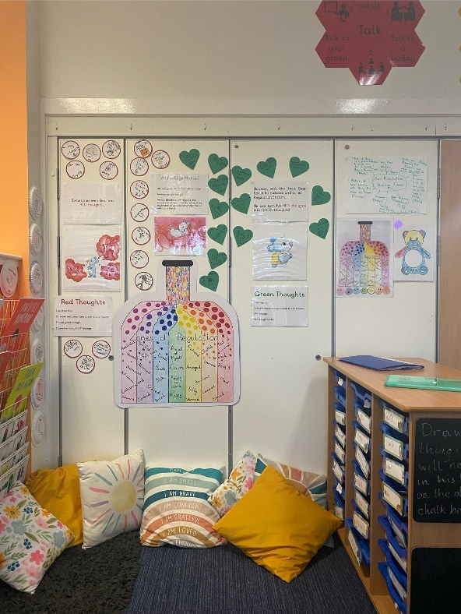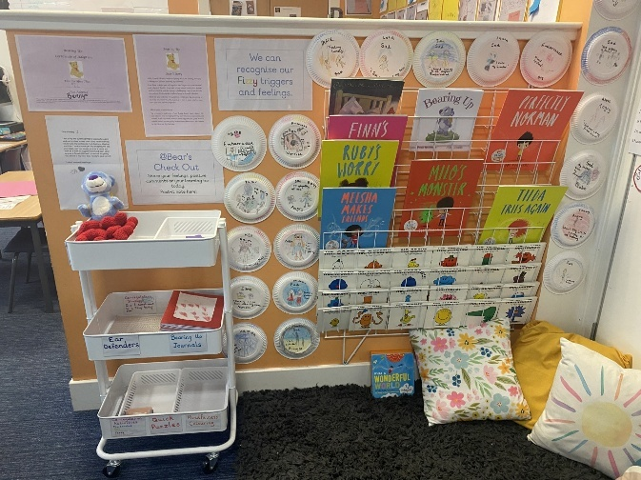

‘Fizzy Feelings’ Regulation Strategy/Steps – used in conjunction with Regulation Station/Trolley/Regulation Wheel – can send as a Word Document.
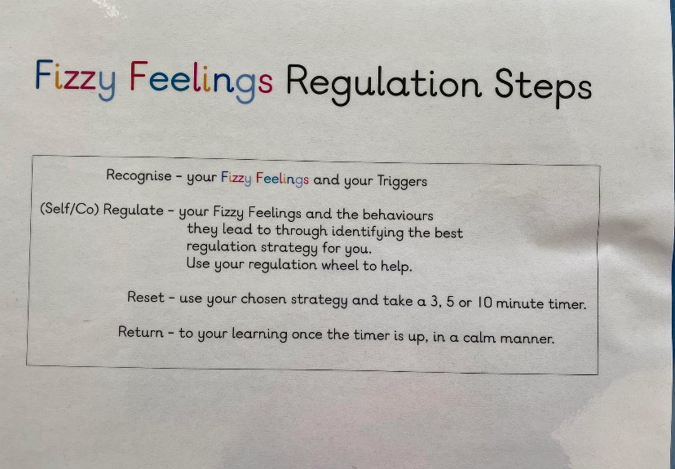

Regulation Wheels/Wheel of Happiness – pupils make their own see included lesson plan.

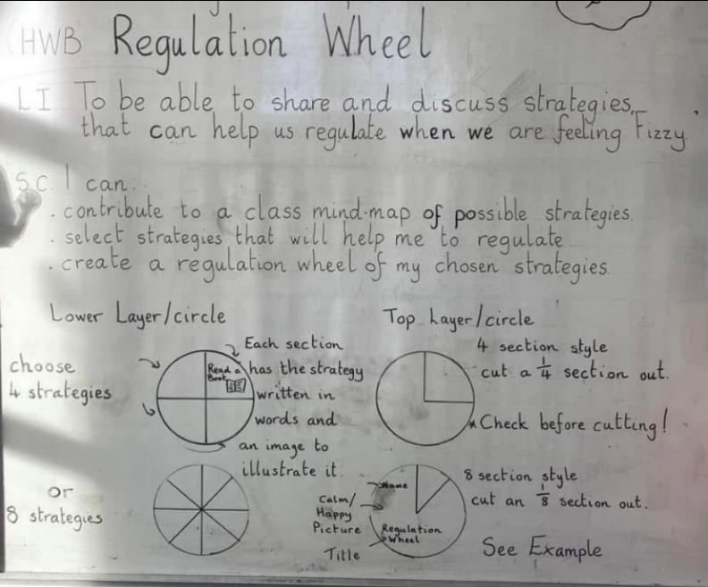.
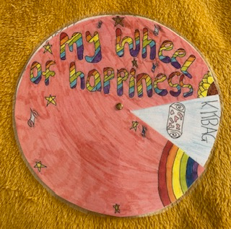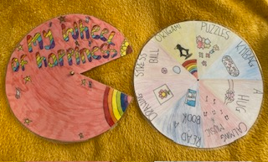

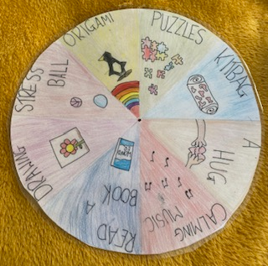
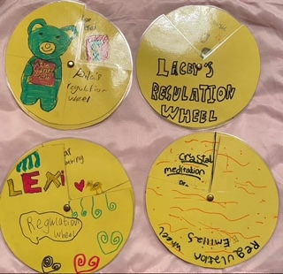
Example Ideas for Regulation Strategies/Wheel of Happiness – come up with these with class. (Pupils may come up with more/different ideas to suit their needs.)

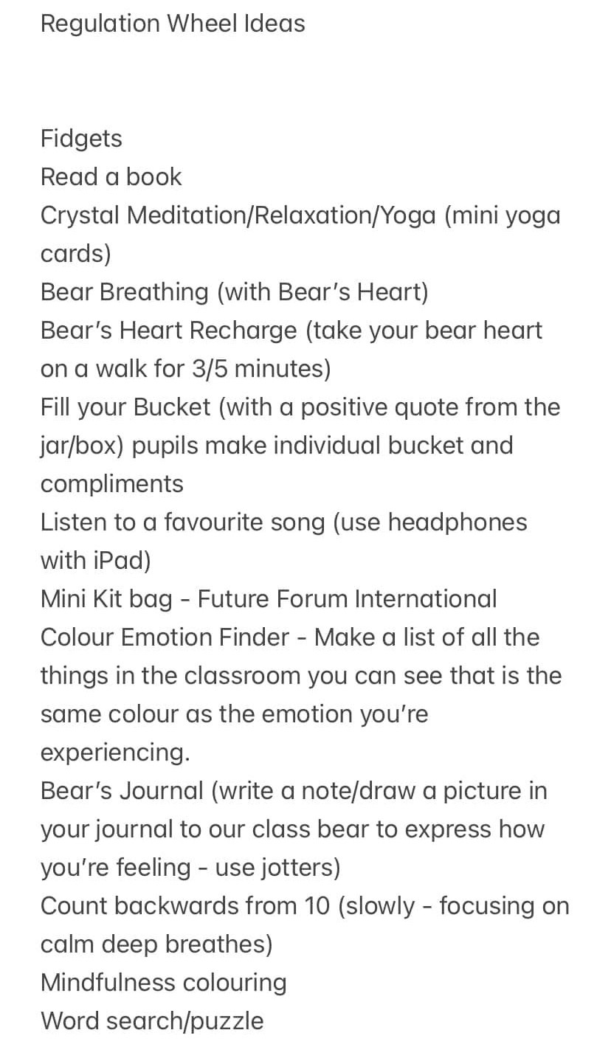

Motivational Stress Balls/Stress Balls – (Example set in photo from Amazon £8)
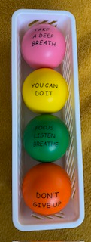

Timers – Various Educational Websites – (Example set in photo from Amazon £10)
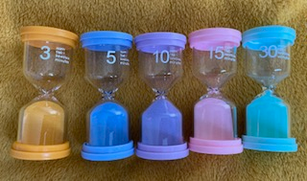

(Real) Crystals – various types. The Psychic Tree Website. Prices start from £1 per crystal.
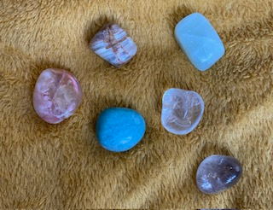
Essential Roller Ball (3Pack) – Use for mini kit bag activities, relaxation, meditation strategies etc… – Example from Amazon £8
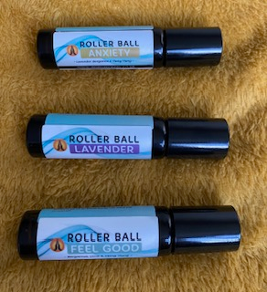

Yoga Cards/Books/Apps – Available from numerous sources. Example Photo Yoga Pretzels Cards available from World of Books (Between £10-£13)

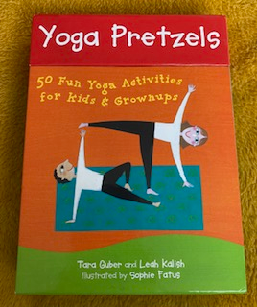

Growth Mindset Awards/Certificates – Can make own as an alternative. Example from
PTS (Primary Teaching Services) £3 for 20. Various stickers also available.
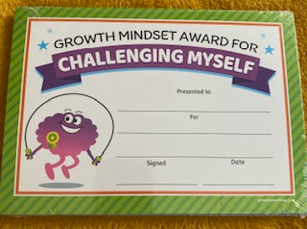

Regulation Strategy Cards – Make own to meet needs of the pupils and strategies on offer. Example Photo.
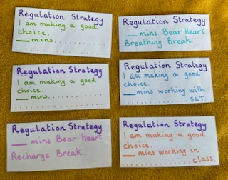
Other resources can include – Lego, mindfulness colouring, quick word/number puzzles, card games (Uno, Snap, Monopoly 15min card game), code breaker etc…

Strategies linked to the 32 Decider Skills – Primarifying and setting a context for the Decider Skills through a ‘Bearing Up’ Approach. Example photos of a couple of the skills. All 32 can be sent as a Word Document.

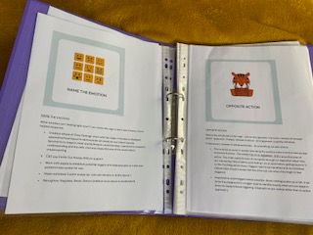
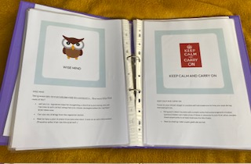

Mental Health Rucksacks/Toolkits – pupils can design their own (once mind mapped strategies alongside or instead of Regulation Wheels/Happiness Wheels).
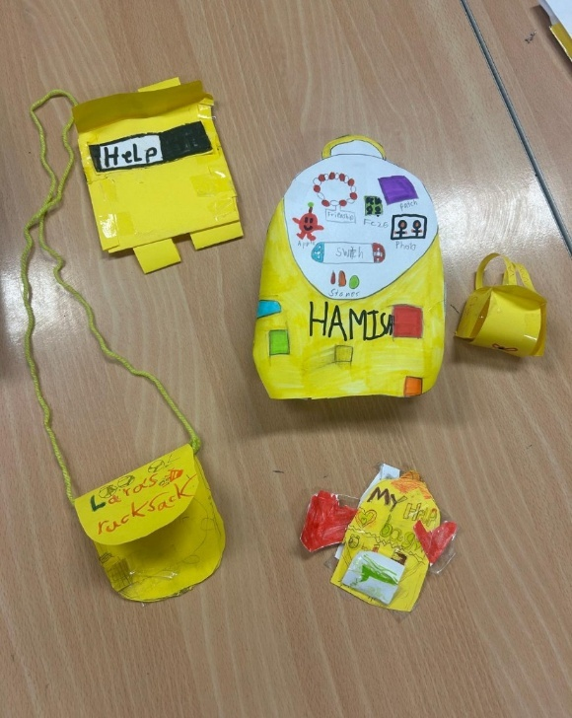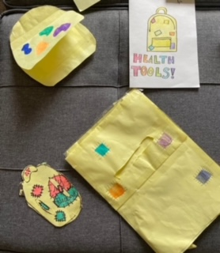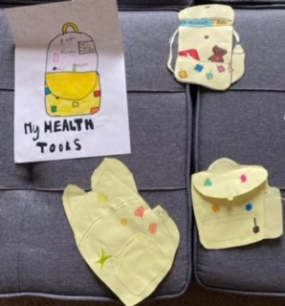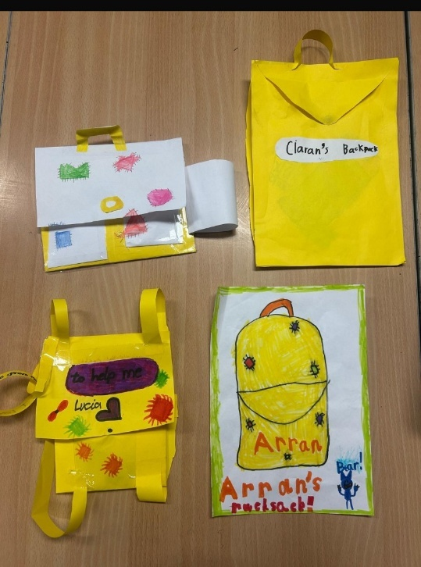
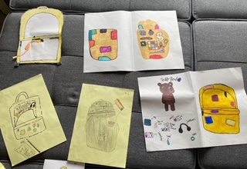
Personalised 5 Point Scales – pupils can make their own 5 Point Scale linked to their likes/dislikes to support and embed understanding of the 5 Point Scale. Can be a Bottle design. Volcano design, Plain design or other ideas generated by the pupils. Example of Volcano design.
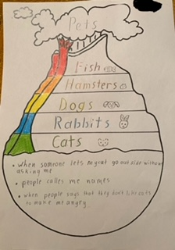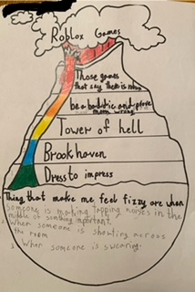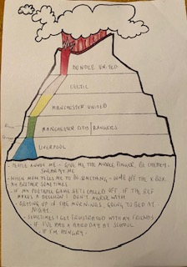

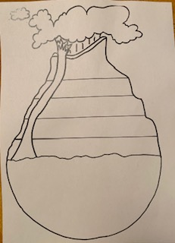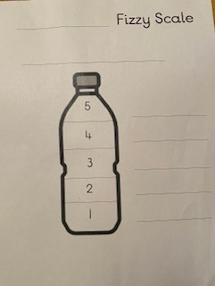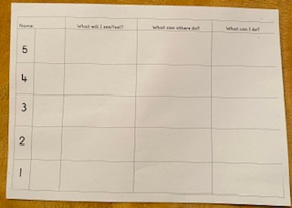

Bearing Up Journal (or potential for Gratitude Journals) – Pupils can write to bear when they are feeling Fizzy. Opportunity to share feelings/thoughts through writing to bear in a non-judgmental way. Opportunity for CT to get an insight into pupils who are finding it difficult to articulate what/how/why they are feeling the way they are. Potential for teacher to reply as bear in a non-judgemental way. (Older pupils although very aware it’s not bear replying often like to participate too! Can use Gratitude Journaling as an alternative.)
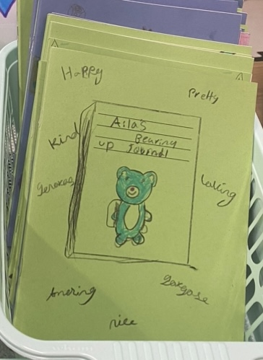
P2 Examples.
Option to comment and sign from Bear! Can link to other curricular areas.

Bearing Up Bear – Our own and Growth Mindset/Mental Health Picture Book. (Although any bears can be used.) Each school or class to have own bear(s). Linked with a heart for each child. Community can get involved in making your (Knit/crochet/felt) bear hearts. (See Bear Necessities for links on how to use Bear’s Hearts). Linked to Attachment Theory/ACES.
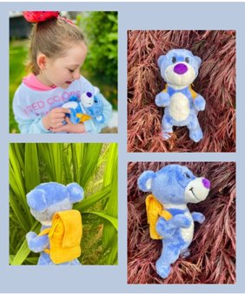


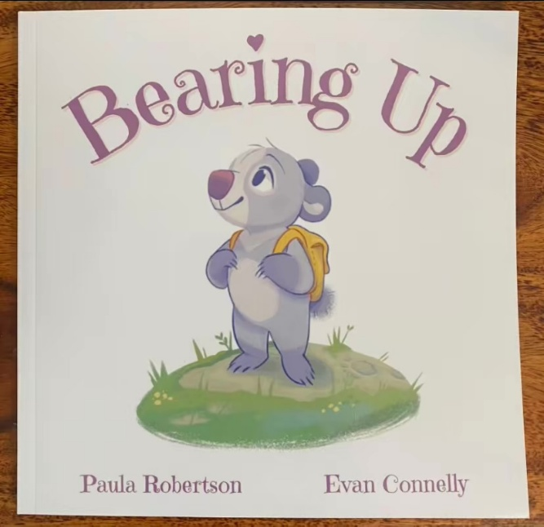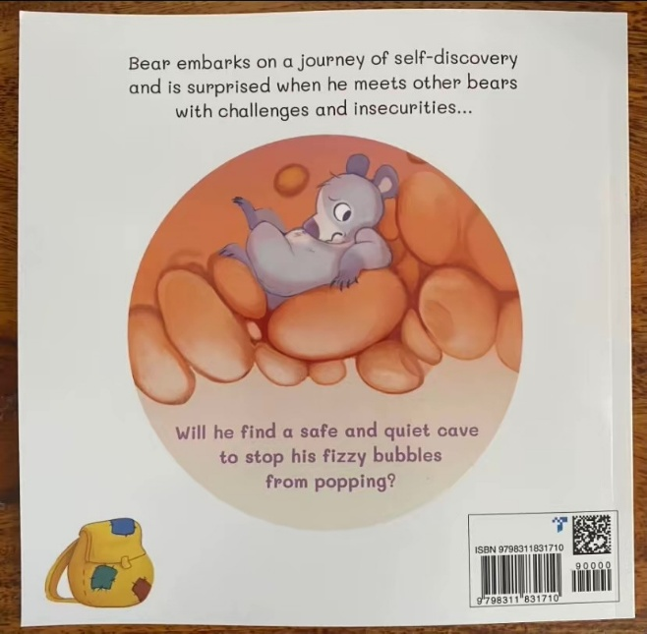
Independent Book Review from an established author.
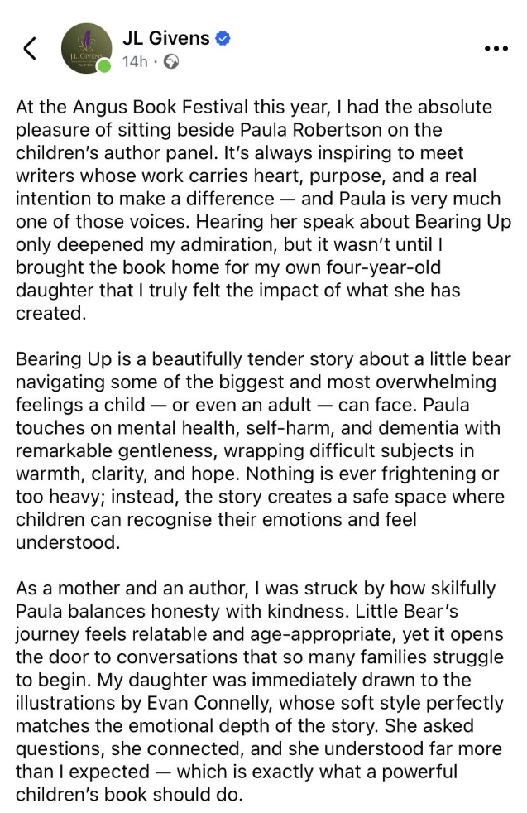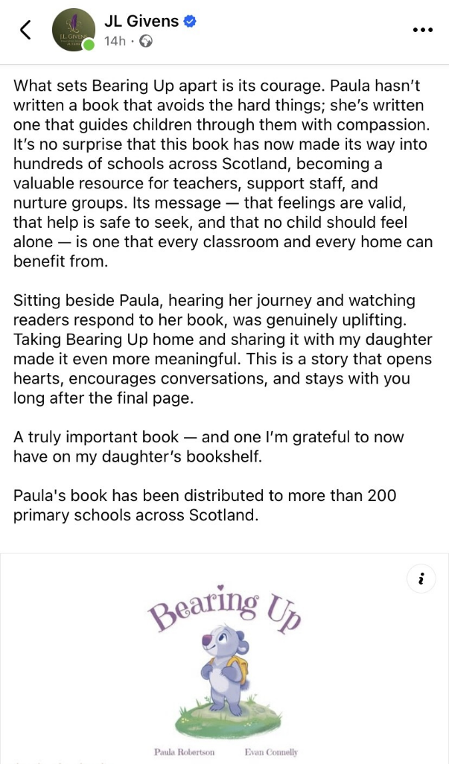

Synopsis - Bearing Up

Also available is an accompanying guide for analysing the story/text - PDF
Musical adaptation of the picture book with Curriculum links for embedding into your planning - both as PDFs

Bearing Up 🐻💖Book Overview 💖
All Bear wants is a quiet calm cave to stop the fizzy bubbles from popping! Bear embarks on a journey of self-discovery and is surprised when he meets other bears who have their own challenges and insecurities. However, in Bear’s trusty rucksack he has just the thing…
A multidimensional story that is cleverly layered and suitable for children (Early through to Second level). The rhyming and repetition are sure to keep all young audiences hooked. It touches on some obvious and some well-hidden themes throughout the text. These include bullying, image/body dysmorphia, loneliness, isolation, challenging environments, being a young carer, grief, loss, dementia, aging/age discrimination, intrusive thoughts, anxiety and depression, self-actualisation and resolution. Key words and language are used that are highly relevant and current particularly in primary schools to support emotional and physical self and co-regulation. There are hints to the escalation and de-escalation process, Fizz Scale, Decider Skills, breathing techniques, and having a solution focused approach. With a final twist to ensure the reader is left feeling resilient, empowered, and loved.
There are more subtle ideas to unpick enwrapped in this beautifully illustrated picture book of resilience and connection. Packed with new depths to be found with every read, this is sure to be a favourite on any bookshelf!
“Bearing Up was born from my own journey with mental health and is written in such a way that no matter who you are you too will truly see yourself, perhaps for the first time ever…” Paula Robertson
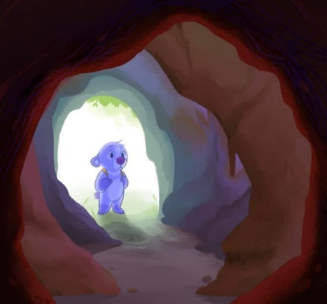
Bear’s Necessities Overview/Ideas and examples can be sent as a PowerPoint
Links to GIRFEC and SHANARRI indicators. (CLPL PowerPoint in the process of being updated to add most recent developments. To be added: Zones of Regulation, Green Thoughts/Red Thoughts, Decider Skills links etc…)
